Mid-Term Group Project: Consumer Insight & Market Research
Group number: 4
Company name: 1FIT


INHA UNIVERSITY IN TASHKENT
CONSUMER BEHAVIOUR COURSE



NAME | ID
Abdumalikov Shohboz | U2411005
Alisherova Marjona | U2411009
Pirimova Shohsanam | U2411039
Tolipova Mubinaxon | U2411052
Turdiboyev Niyazbek | U2411055

April 2026
Table of contents
Executive Summary…………………………………………………………………4
Research Methodology & Evidence………………………………………………….5
Qualitative Insights: The "Why"....................................................................................6
Quantitative Validation: The "How Many"....................................................................8
Strategic Recommendations…………………………………………………………..9
APPENDIX 1…………………………………………………………………………11
APPENDIX 2…………………………………………………………………………12
APPENDIX 3…………………………………………………………………………13

1. Executive Summary

This research, based on a combination of qualitative( 4 In-depth interviews) and quantitative ( 70 surveys) methods, revealed key insights of consumer behaviour on the 1FIT platform.

Main consumer insight
Consumers come to 1FIT because of the emotional appeal of variety and the opportunity to ‘try everything’. However, in the process of using the app their behavior changes from the search for novelty to the need for stability and convenience. When the excitement decreases, users start to evaluate the service from a practical point of view and from this moment the key barriers arise.
Despite the fact that 68.6% of users consider the price reasonable, the main reason for poor retention level is not financial factors but the “service frictions”. This includes time constraints (44.3%), difficulties with booking (38.6%), poor communication and support. The negative attitude from partner halls make the situation even worse.
Consequently, this creates a critical gap between brand’s pledge and the actual consumer experience.

Strategic conclusion:
The current model which was oriented to attract new users through the idea of diversity loses effectiveness on the stage of retaining customers. The core problem is inability to transform short-term contribution to long-term value.

Recommended strategic step for next fiscal year:
Change focus from aggressive attraction of new users to keeping and developing existing bases through service quality improvement.

Key directions:

Optimization of consumer's experience: decrease time limitations and improve reservation system.
Enhancing customer support: transformation from reactive to proactive communication
Transparency of changes: implementation of notification system and informing customers.
Differentiation of tariffs: introduction of flexible plans (including premium access without limits)

Realization of these goals allows to increase customer satisfaction, reduce churn (for now 26.9% do not plan to continue) and build a stable model of long-term loyalty.

2. Research Methodology & Evidence
This research was conducted using qualitative and quantitative techniques to understand how customers feel about 1FIT in Uzbekistan. The goal was to understand motivations, expectations and experiences that determine their decisions.
2.1 In-Depth Interviews
The qualitative part of the study consisted of four interviews each lasting between 40 and 60 minutes. The respondents were specifically selected based on their experience with 1FIT. Some respondents had been using the service for a long time while others had shorter or even stopped the membership. Interview questions focused on fitness habits, awareness of 1FIT and the overall user’s experience. Special attention was given to users’ feelings while being in different stages of their experience. This allowed the team to understand whether they were going from excitement to long-term subscription or eventual disappointment.
2.2 Face-to-face survey
To validate the insights a quantitative survey was conducted with 70 respondents and the data was collected face-to-face with each of them. To reach different segments of people surveys were taken in different locations such as gyms, fitness studios and public areas. This allowed the research team to include both people who are actively training and those with occasional physical activity.
The questionnaire consisted of 25 questions which were based on the insights from four interviews. This allowed the research team to understand whether these concepts were common among a larger group of people or not. The survey included questions related to fitness habits, awareness and usage of 1FIT, decision-making factors and future intentions. Most of the questions were in multiple-choice format and likert scale which made it easier to build statistics.
2.3 Research Validity & Documentation
Four deep-question interviews were included in APPENDIX1, photo evidence of 70 respondents and scanned questionnaires in APPENDIX2. An original sample of the questionnaire was put in APPENDIX3.
3. Qualitative insights “WHY”
A series of 4 qualitative interviews was conducted with 1Fit users, including both current users (Zilola and Shomurod) and former users (Aziz and Ibrohim). The results of these in-depth interviews illustrate that the key reason of an interest towards 1Fit is the emotional attractiveness of diversity and a chance to investigate. Users perceive this platform as a way to try different activities without the need to fix their choice in one option and to improve it. It lowers the risk of a wrong choice and makes the decision of purchasing a subscription a lot easier.
3.1 Emotional motivation
In the introductory stage, the service evokes a strong emotional response, related to newness and interest. For example, Zilola stated that at first weeks after purchasing, she had an interest to try everything and be an active user by attending all of the studios, until she literally attended every studio nearby. Analogically, Ibrohim described his experience as an opportunity to go beyond habitual training by trying different activities such as boxing, horse riding and archery. It demonstrates that the platform successfully fulfills the need for new impressions.
However, this kind of motivation is gradually lost. When the newness effect disappears, users start estimating the value of the service once more with another point of view including practical and comfort issues.
3.2 Consumer path
The interview analysis made it clear that a typical consumer path includes several stages.
In the first 1 or 2 months, the feeling of novelty and involvement dominate the process. 1Fit owner uses the platform actively by trying various studios and gyms and gets a positive experience. As Zilola mentioned: “The first 2 months were very interesting, I tried everything.”
On the next stage, when approximately 3-6 months pass, there is an appreciable shift in consumer behavior. The user either starts forming a habit or faces a choice overload problem. An example is the situation Aziz, the former user of 1Fit faced. He said that over time he came to the conclusion that he needs only one gym and started attending one place all the time. Relatively, it lowered the value of the subscription. At the same time, Shomurod, who has been using this service for three years already has formed a stable routine and he attends concrete activities regularly, such as table tennis.
After a 6-month usage there is a dividing point: a part of the users continue being active and using the service because of their formed habits, but another part loses interest and stops using it. It happens due to the fact that the initial value of diversity gives way to the need for stability and comfort.
3.3 Main motivational factors
One of the key factors is social effect. All respondents came to know about 1Fit through their surroundings – through relatives, friends and other acquaintances. It significantly increases the level of trust to the service. Additionally, the referral system strengthens the spreading of the product: in the interview with Shomurod, it was found that he invited around 20 people as it was profitable for both sides.
The second important factor is the feeling of flexibility and control. An opportunity to choose different locations and manage with the subscription creates an impression of a comfortable and adaptive service. However, this advantage is partly leveled out by limitations. Thus, Ibrohim highlighted that time constraints do not correlate with his daily lifestyle: “An ability to attend only from 13:00 to 17:00 does not fit my schedule”. These kinds of limitations reduce the perceived service value.
Besides that, users stated the gap between the expected simplicity of usage and the real experience. Among the problems were the overfilled activities, additional expenses and weak support work. For example, Aziz expressed his dissatisfaction with intrusive calls: “They called me every time I accessed the application”. Also, Shomurod encountered sudden changes in booking limitations without any preliminary notifications.
When all these factors are taken into account, they explain why users can refuse to use the application despite the positive attitude towards the idea itself.

4. Quantitative Validation: The "How Many"
4.1 Who are our users? (Demographics)
The survey was gathered from a sample of 70 people. Most of them are young and active like interviewee Zilola. 57.1% are aged 18-22 years old, and 64.3% are students. These power users go to the gym 3-5 times per week (58%), and because they are frequent users, the frustration of the booking limits has gone from being an annoying inconvenience to a significant part of their day.
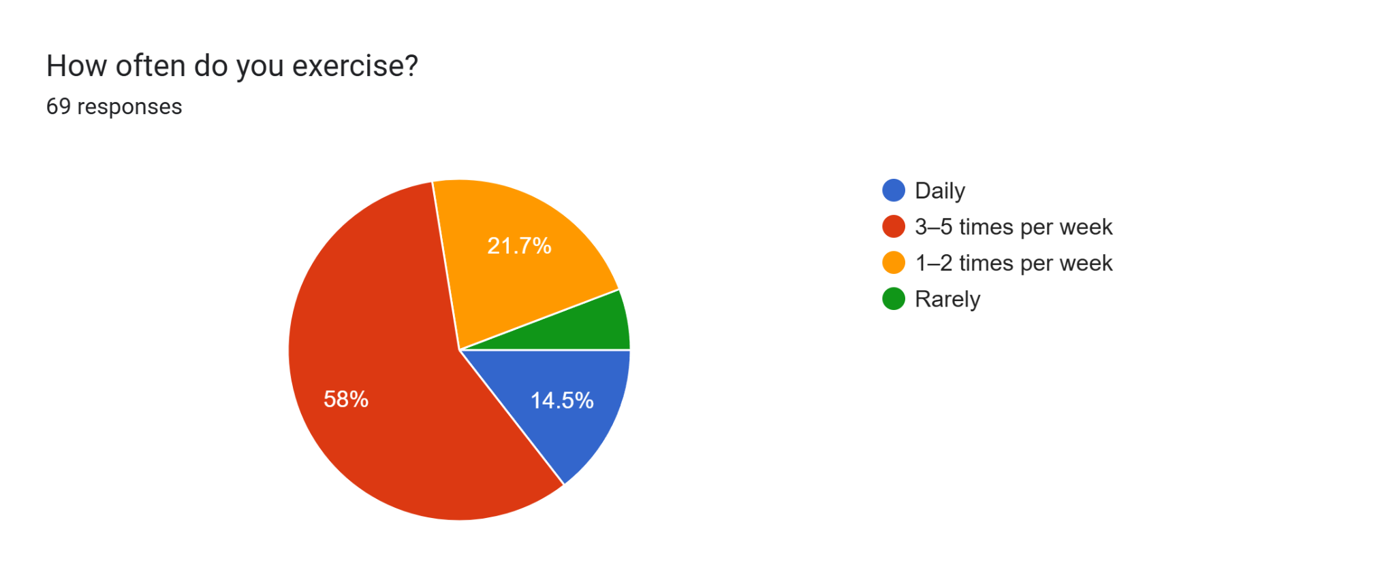
4.2 The Variety Paradox: Why we buy vs. What we do
The paradox appears when the customer loses his/her interest in trying other options and sticks to familiar options, as in the example of Aziz aka. Survey data supports this, while almost everyone (82.9%) says they love the idea of having many gyms to choose from, nearly half (42.9%) actually prefer going to one regular place. Thus, it appears that variety is an emotional hook that attracts users to the app; however, once excitement wears off, the majority of users will begin questioning whether or not they require continued access to the app.
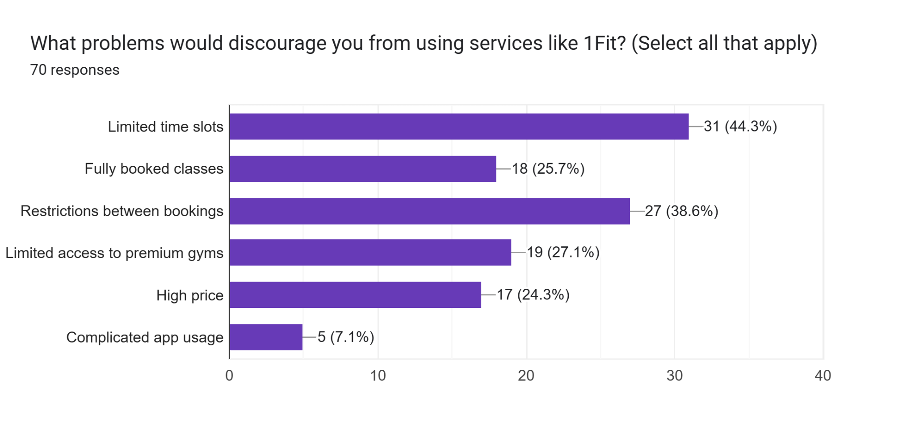
4.3 What’s actually driving people away? (Price vs. Service)
The reasons for quitting 1Fit were surprisingly not the cost. This survey showed that the majority of the respondents felt the monthly cost was fair. In fact, 68.6% of the users indicated that they believe the monthly charge for 1Fit is fair, while only 24.3% complained about the high cost. The break points actually are time slot limitations and booking restrictions that make up 44.3% and 38.6% each, respectively. It indicates that users are happy to pay, but they aren't willing to fight the app just to get into a workout. As Aziz and Shomurod suggested, the "service friction" is now bigger than the value of the service.
4.5 The “cheap client” and Renewal Projections
Finally, there is a problem with the bad attitude of staff in some gyms, and 31% of 1Fit users have felt that they are being treated less respectfully. The reason for that is gym staff perceive 1Fit users as cheap clients in comparison with customers with their own membership. The combination of this problem with the frustration over booking slots, the result is a serious warning for the company: 26.9% of our users do not plan to renew. This isn't because they don't like fitness; it’s because the "discovery" excitement has faded, and the practical problems have taken over.
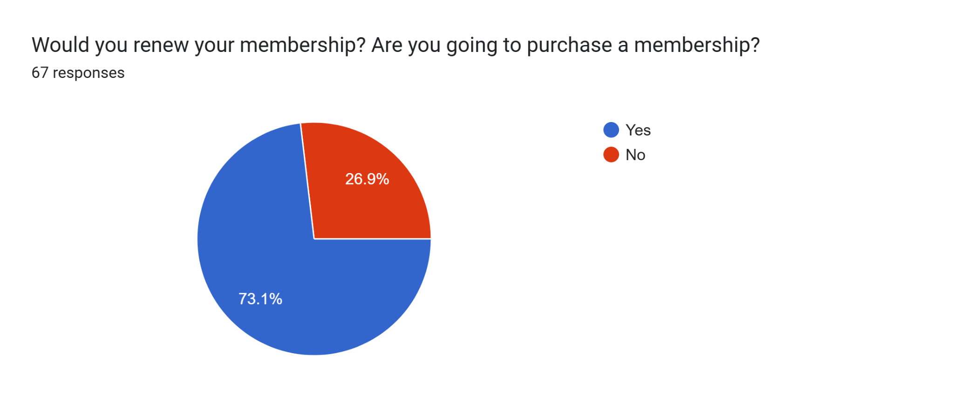

5. Strategic Recommendations and Improvements for 1Fit
Three main problems have been detected during conducting interviews and analyzing the results of surveys. These problems are ineffective customer support for existing users, lack of information regarding changes and time constraints.Below, you can see the list of strategic recommendations considering consumer behavior and the efficiency of business processes.
5.1 Recommendation: Improvement of Customer Support for Existing Users
Based on the analysis of the obtained findings, it would be recommended to 1FIT to pay attention to enhancing the service for its current users rather than gaining new clients. Current members of 1FIT suffer from many problems regarding their experience with services, including inefficient communication, unsolved issues and ineffective customer support channels like call centers.
Thus, this situation leads to dissatisfaction of clients who already started using the application but feel the lack of good service, although they may appreciate prices charged for it. At this stage, despite the fact that they may like the price policy, they are inclined not to continue being the clients due to dissatisfaction from services.
This way, they will retain their customers and make them loyal.
5.2 Upgrade of Customer Support Mechanism
One more aspect concerning the negative experience with the application is lack of sufficient information regarding changes implemented in its function.
In order to solve this problem, it would be reasonable to implement the new change policy, including notification of all changes via e-mail or push notifications, and the description of the updates. It is recommended to add a section 'What's New?' in the application.
5.3 Optimization of the Time Limitation Feature
Time limitation turned out to be a noticeable problem, since it limits users' freedom and doesn’t coincide with their routine, thus decreasing the value provided by the service.
To solve this problem, it is necessary to improve the existing annual tariff(12 month) and create two variants of it, one limited by time, and another unlimited but available only for those who pay more for it. In other words, users will be able to decide whether to use this service cheaply and restrictedly or with higher costs but with unlimited possibilities.
This will help in increasing user retention rate and providing additional satisfaction from using the service.

APPENDIX 1 (Interviews): https://drive.google.com/drive/u/0/folders/1vtiqH-JEts8Hq4TCbAEk0-xerdGBYyvm

APPENDIX 2 (Survey Results): https://drive.google.com/drive/u/0/folders/1vtiqH-JEts8Hq4TCbAEk0-xerdGBYyvm

APPENDIX 3 (Survey Example Sheet): https://drive.google.com/drive/u/0/folders/1j224RyJfq_s8BBfwoZIOILmZ5LXYukZi

